1.Login Module & Ending Screen

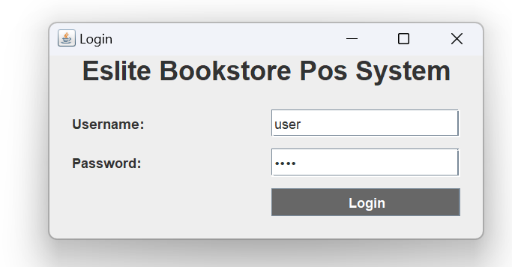

The login screen will prompt after running the java file.

Username : user

Password: 1234

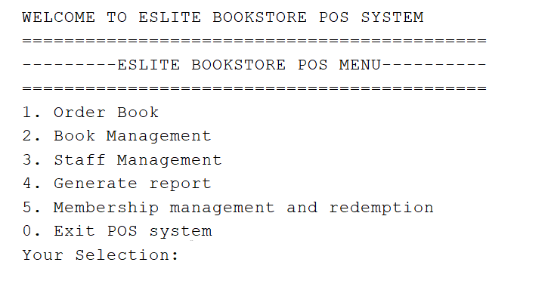

if the credentials are correct it will go into the POS main menu.

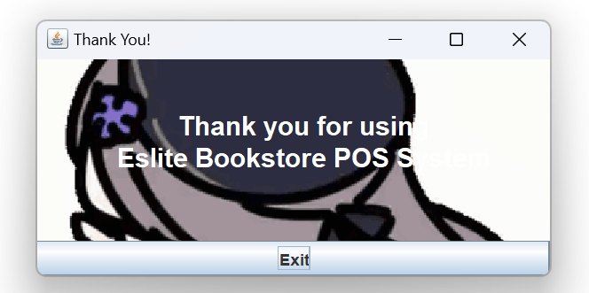

After exiting the POS system a Thank you window will be prompted.

2. Member Module

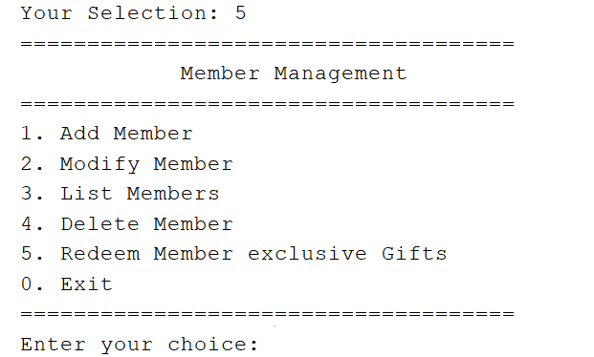

After typing 5 in the main menu , it will bring the user into the Member menu.

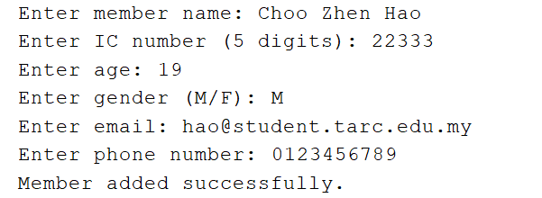

If you choose 1 to add a member , it will ask you to key in all information.

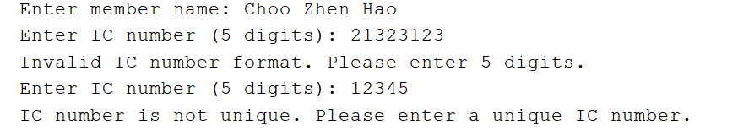

For the IC number , it must be unique , else it will not be recorded into the system

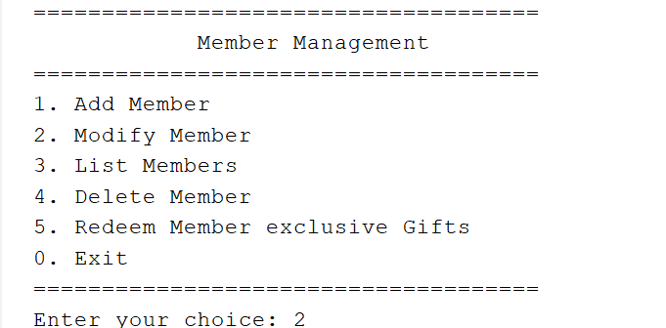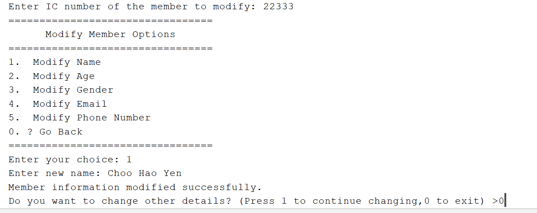

After you choose to modify a member , it will ask the user to enter the IC number of the member the user wants to modify.

It will list out all the members currently registered in the system if the user chooses to list out all the members.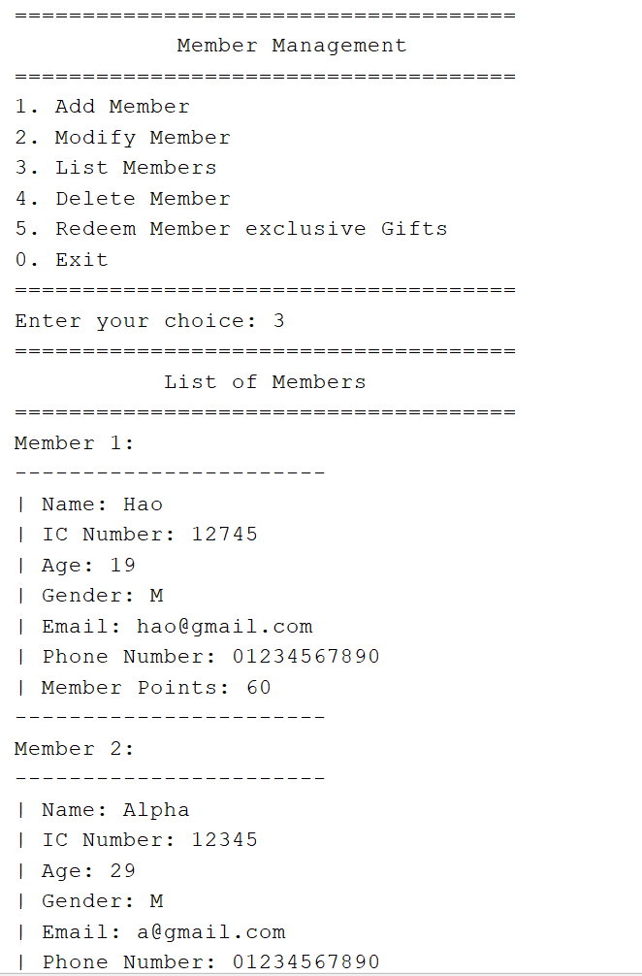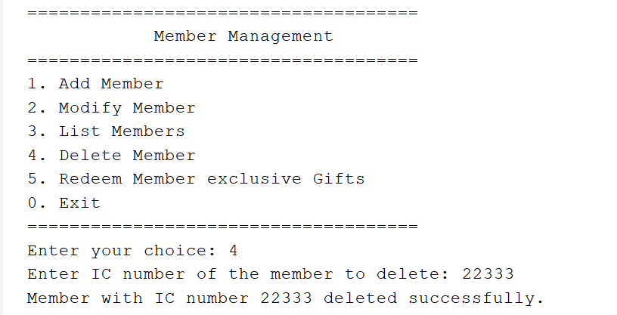

Member's information will be deleted from the system in the delete member function.

Users can redeem exclusive gifts using their member points. There are 5 items to redeem.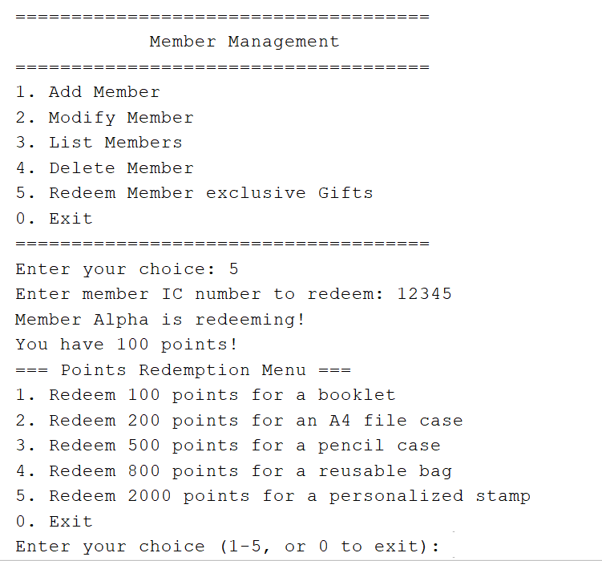

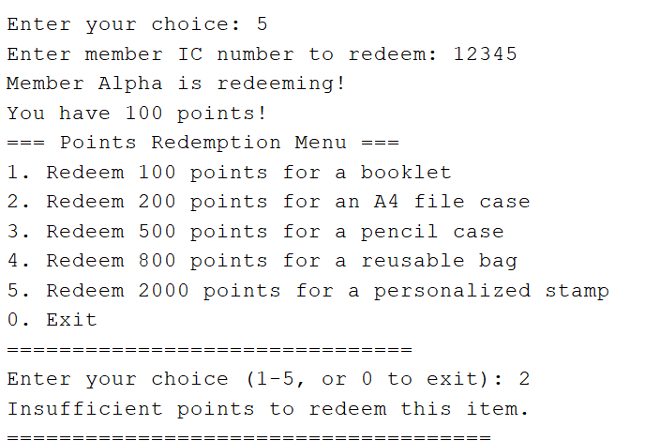

If the member doesn't have sufficient points , it will not be redeemed.

It will show the user how many points the member had , and how many points the member has after redeeming gifts.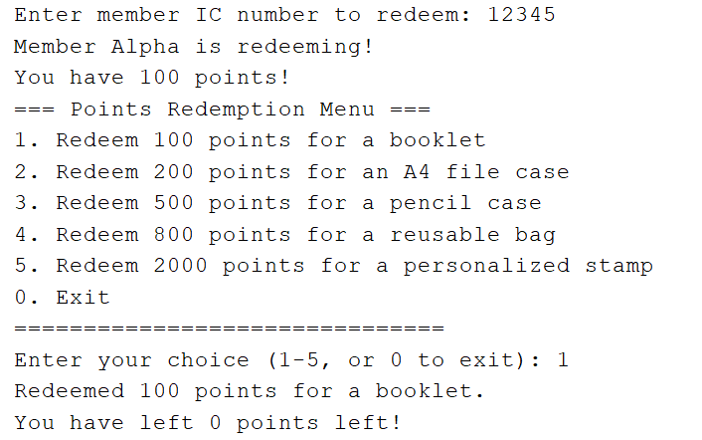

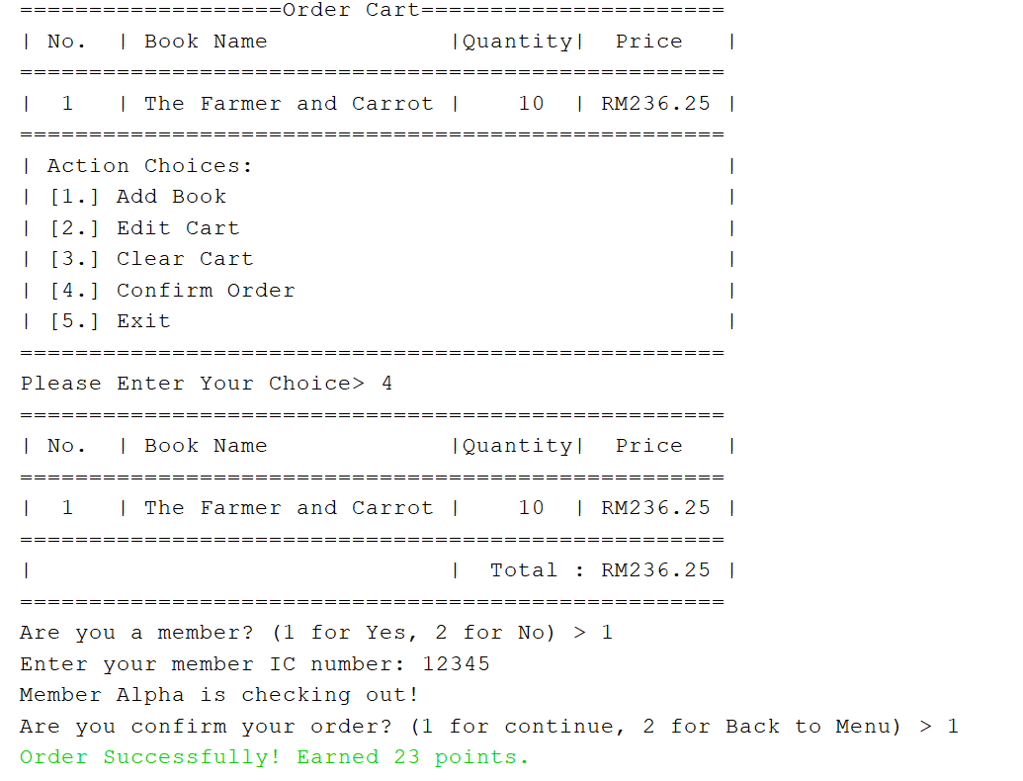

The points are earned when a member buys books from us , with the rate of 10% of total purchase amount (decimals are ignored).

3. Staff Module

3.1 Staff Confirmation Page

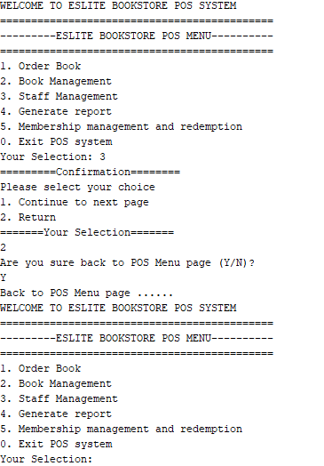

After the user chooses the Staff Management, it will show the confirmation page, if the user chooses "2", then the system will go back to the main POS Menu. Else, if the user chooses "1", then it will show the Staff Main Menu.

3.2 Staff Main Menu Page

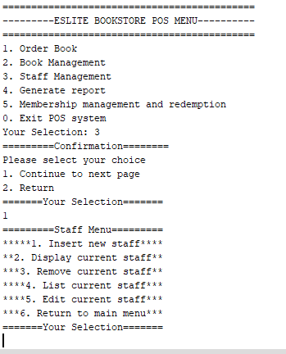

Staff Module provides 5 main functions, which are insert new staff, display, remove, list and edit current staff. There is an extra selection which is "6", returning to the Staff Main Menu.

3.3 Insert New Staff Function

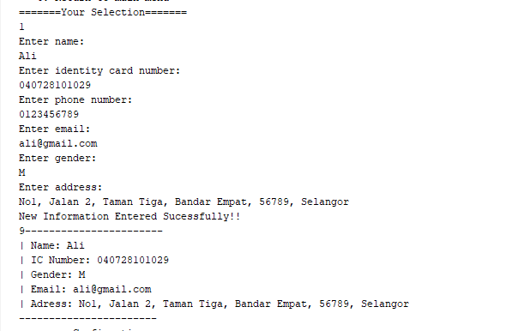

This function requires the user to insert the new staff's personal information. Information such as name, ic number, gender, email and address is basic information that will be stored by the bookstore. After that, it will show the information that the user entered.

3.4 Display a Current Staff Function

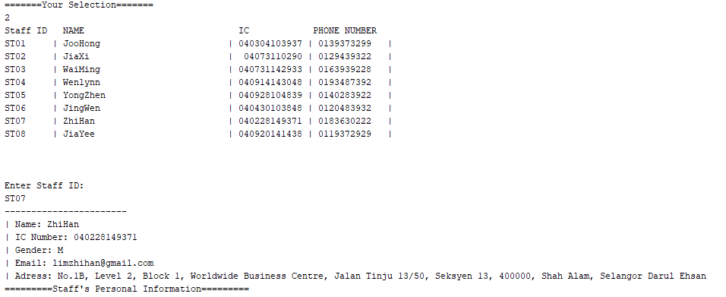

This function acts to show a staff member's personal information. It will require the user to enter a Staff ID. After the user enters the Staff ID, then it will display the personal information.

3.5 Remove a Current Staff Function

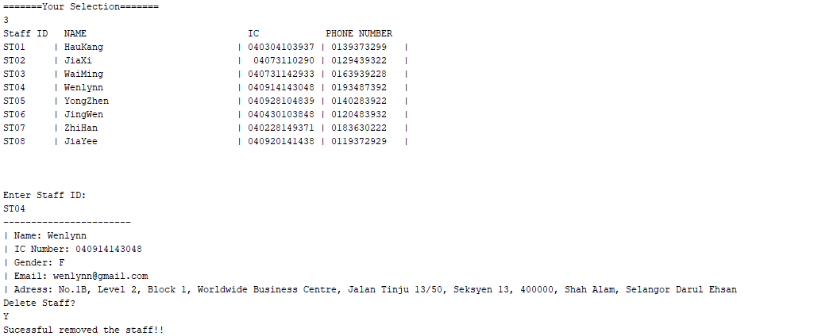

This function acts to remove a current staff member. Same as 3.4, it will show the personal information first. After that, it will display a confirmation page. If the user types "Y", then it will remove the staff member, else it won't remove the selected staff member.

3.6 List Current Staff Function

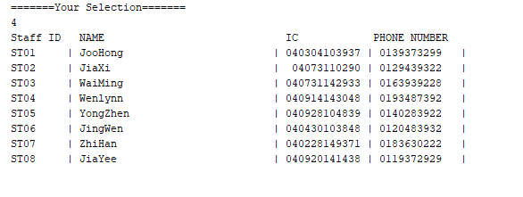

This function acts to show the full staff members and their own personal information. It will display the Staff ID, Name, IC and Phone Number.

3.7 Edit Current Staff Function

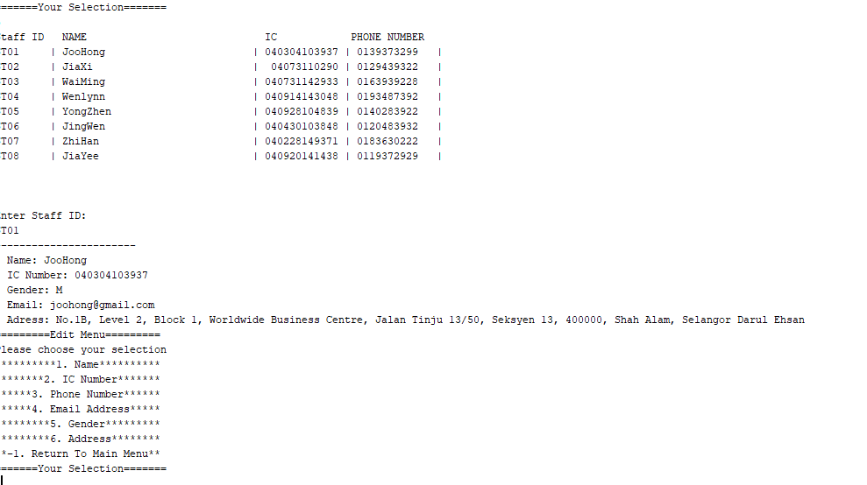

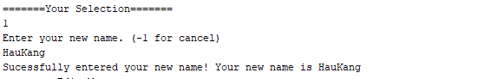

This function acts to edit a current staff member's personal information. After that, it will show the edit menu. There are 6 selections that user's can choose to edit such as name, ic number, phone number, email address, gender and address. Once the user chooses their selection, then it will require the user to input the new information. Then, it will show the successful message and show the updated information.

3.8 Return Main Menu Function

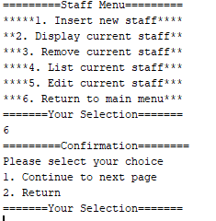

Same as 3.1, once the user selects "6", which is "Return to main menu", it will go back to the Confirmation Page.Choose "2" to back to POS Main Menu and "1" to continue in Staff Module.

4.Order Module

4.1 Order Menu

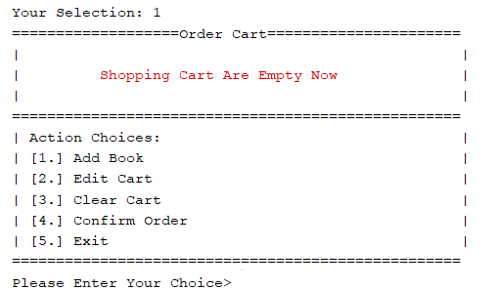



For order function,it is more likely like a cart for book ordering.After press ‘1’to enter order function,this order cart menu page will be displayed.As there are nothing been adding to the cart yet,so the shopping cart is empty now.There 5 action can be taken in this menu.If user no inputted selection between(1-5),error message will be displayed.Selection ’5’ for exit the order page and return to the main menu page.

**4.2 Add Book**

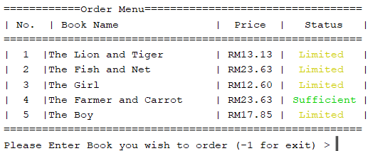

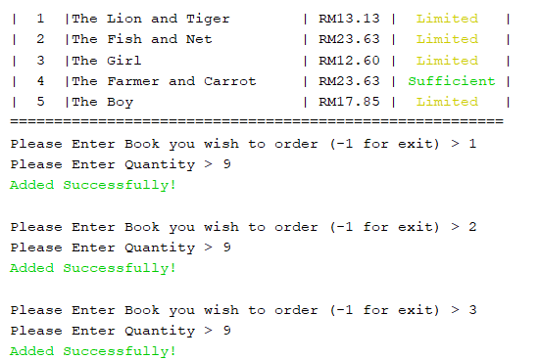

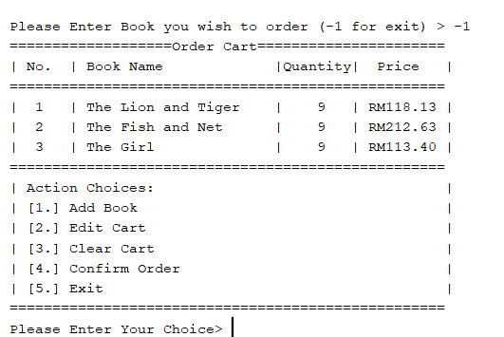

After pressing ‘1’,the order menu page will be shown.Book name,price and status for each book will be shown.For price,the order price will have 5% increasing from the actual price.For book status,its will evaluate from the stock available,if the book quantity is more than 50,the status is sufficient,the quantity is lower than 50 and more than 0,the status is limited while when the stock quantity is 0,the status is out of stock.Then,user can input the no. of book and enter quantity for each book to add that particular number of book into order cart.The successful message will be shown also after the user add item into cart.User need to enter(‘-1’) to exit the adding cart function and back to the order menu.Now,in the order menu,ordered book’s name,quantity and price will be displayed in the order cart.

**4.3 Edit Cart**

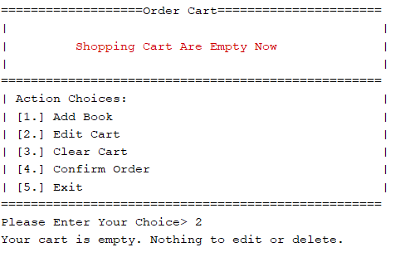

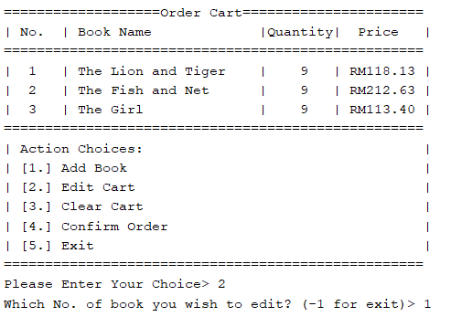

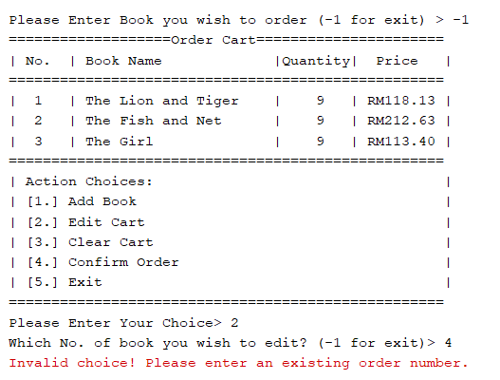

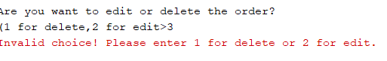

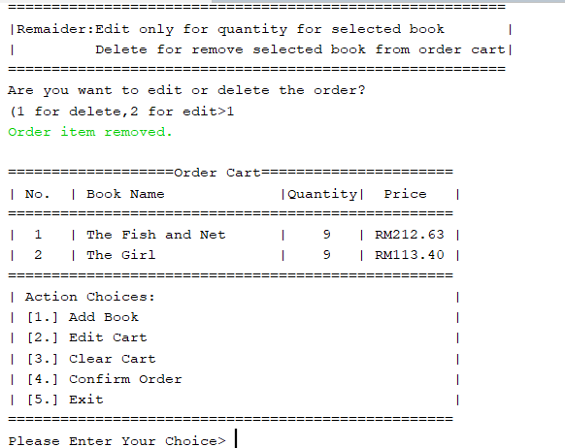

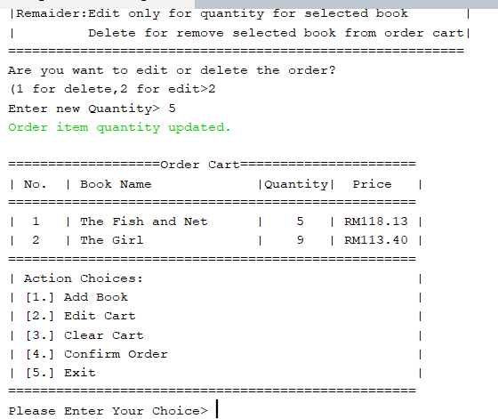

After pressing ‘2’,it is an edit function for the order cart.When the order cart is empty,its wll display error message to the user mentioned that the cart is empty.This function only applicable when the cart have items.When the cart have items,its will prompt message and let user to select which no. of book that user want to edit and (‘-1’) to return back to order menu.If user input the no. book that no in the order cart,its will prompt error message and return back to the order menu.After user input valid no. of book,there are only 2 actions can be taken,1 for delete the items from the cart,2 for edit the quantity of that particular book.If user input selection other than these 2 options,error message will be prompt and return to order menu.When user enter 1,successful message will be displayed and that book will me removed from the order cart.After user entered ‘2’,its will prompt message and ask user to enter new quantity for that book as only quantity can be edit.After edited,successful message will be displayed and the quantity of that book will be updated in the order cart also.

**4.4 Clear Cart**

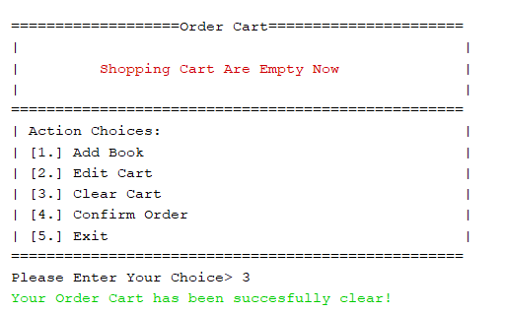

When the user enters ‘3’ in the order menu,this will clear the whole details in the order cart.After clear the whole cart,successful message will be displayed.

**4.5 Confirm Order**

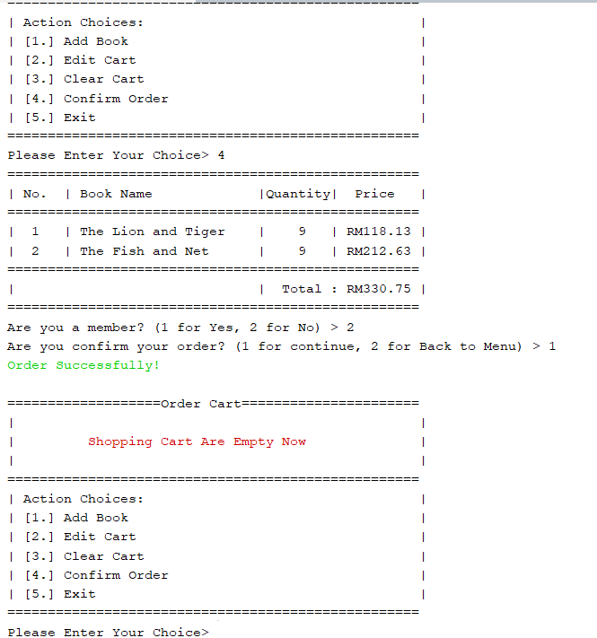

As the items in the order cart are not finalized,its can still be customized and adjustable.When user enter ‘4’ in the order menu,its will show all the details in the order cart and sum up all the price and display the total price for the whole order.Then,a message will been prompt that ask user whether is a member or not as member points part will been integrated here.After that,a message will prompt and ask user want to continue or back to menu.If continue,means that user confirm their order details and submit the order,then successful message will be shown.This part will be integrated in the book management part also.The original stock quantity will be reduced.

Initial details:

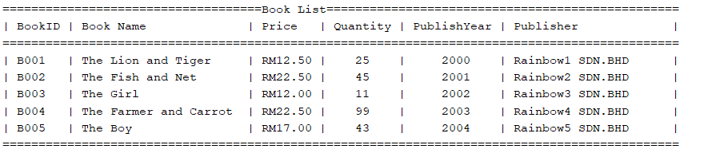

After order:

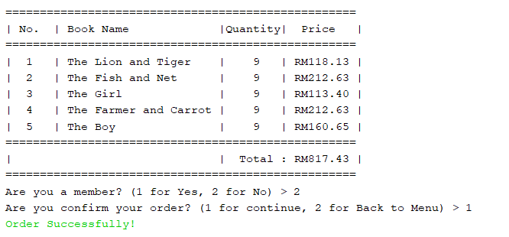

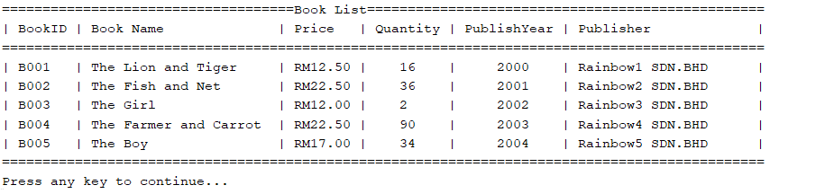

5.Book Management Module

**5.1 Book Management Menu**

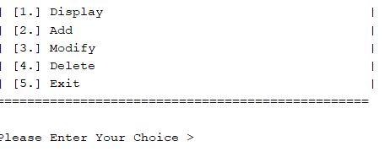



After the user enters ‘2’ in the main menu,then the book management menu will be displayed.There are 5 selections for user’s selection.If user enters a selection other than this,error message will prompt. ’5’ for users to return to the main menu.

**5.2 Display Book**

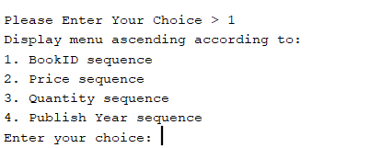

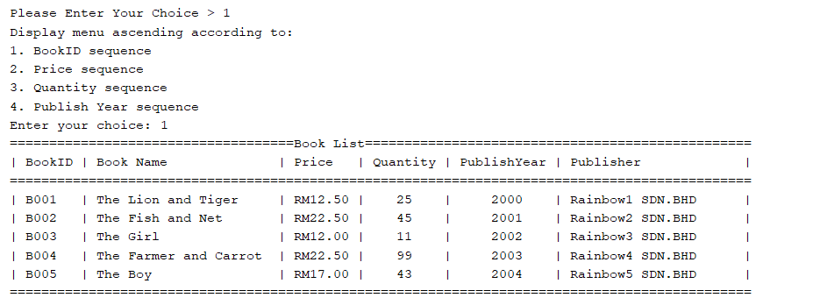

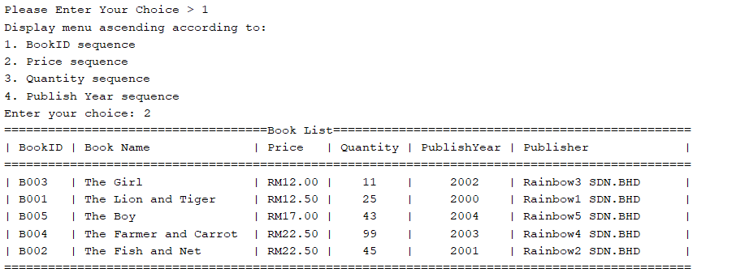

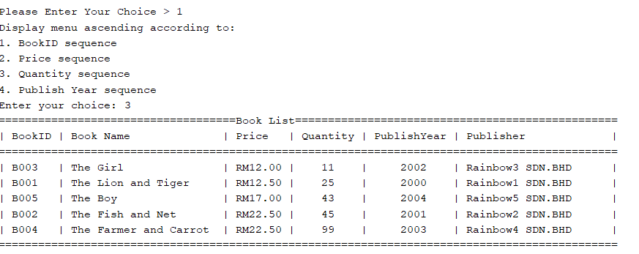

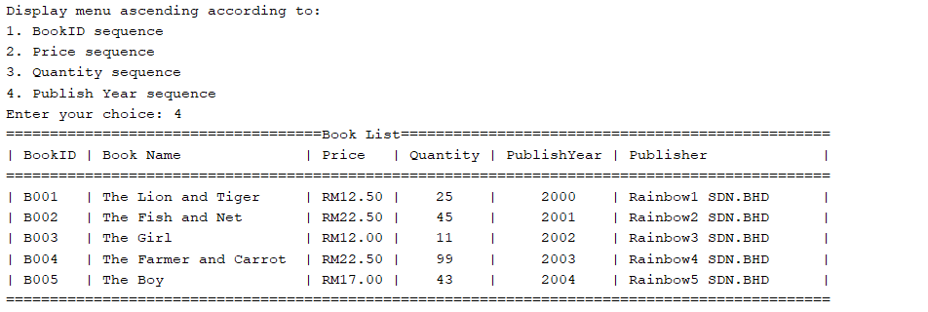

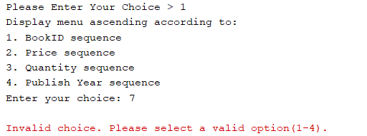

After the user selects ‘1’ for display function,there will be 4 ascending sequence arrangements for the user to select(bookID,price,quantity,publish year).After selection,the book stock’s details will be displayed according to the user's selection sequence.There will be error message prompt if user entered selection out of 1 to 4.

**5.3 Add Book**

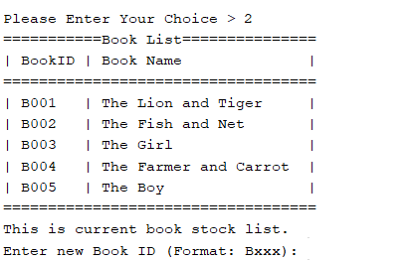

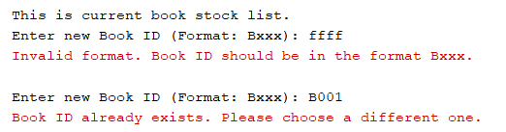

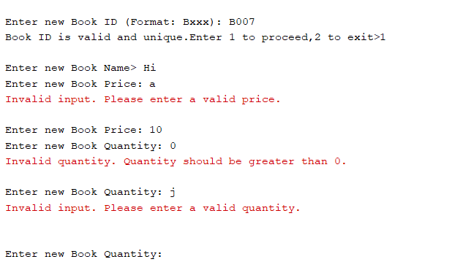

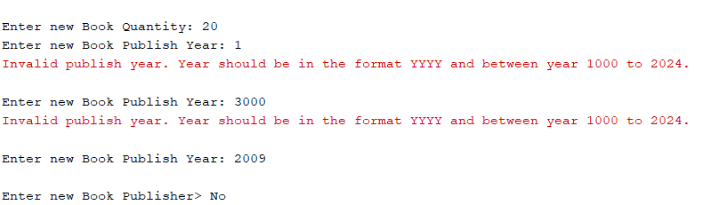

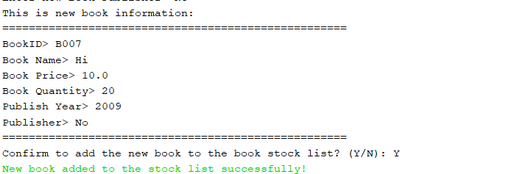

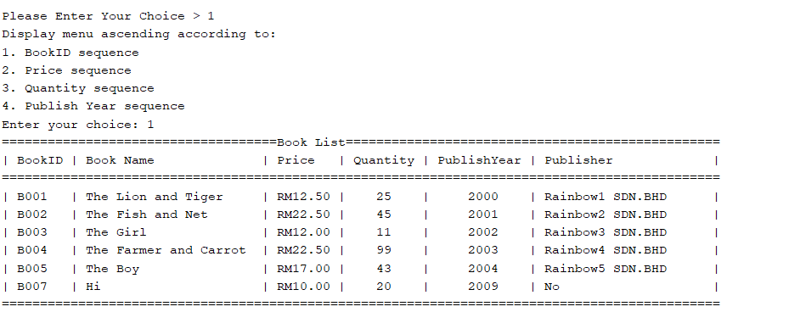

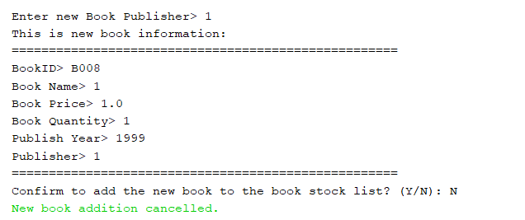

After the user enter ‘2’ ,current book stock list will be displayed.Then,message will be prompt to ask user to enter new book id with format Bxxx.There will be existence validation and format validation here,if bookID entered is not follow the given format or the bookID are exist in the current book Stock list,error message will be displayed and ask user to enter the Book ID again.After the BookID is checked,t=successful message will be displayed and ask user whether want to continue or not,1 to continue,2 for return to the book menu.After user enter 1,the program will continue to prompt message to ask user to enter new book name,book price,book quantity,publish year and publisher.There are validation for price,quantity and publish year.When the price are less than 0,or not numeric number,its will prompt error message.When the quantity are less than 0 or not a numeric number,its will prompt error message.When the publish year is not between year 1000-2024,error message will be prompt also and ask user to enter again.After all information have been entered,its will displayed whole details keyed in and ask user whether want to add new book or not.If user entered ‘Y’,successful message will be displayed and new book will be added to the book stock list.If user entered ‘N’,then the book addition will be canceled and cancel message will be displayed.

**5.4 Modify Book Details**

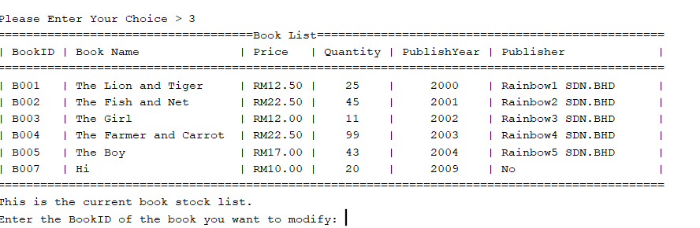

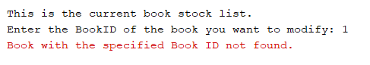

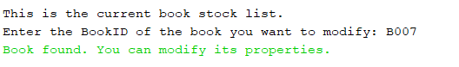

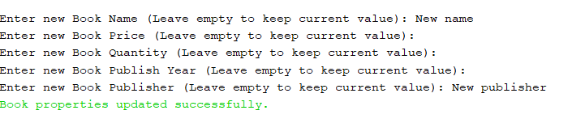

After the user enter ‘3’,it is a modify functions for the existing book stock list.First,current book stock list will be displayed.Then,message prompt will ask user to enter bookID.If the bookID is not found,the error message will be displayed and return to the menu.If the bookID found,successful found message will be displayed and let user to continue to input the new details.Here have same validation with add book functions.If user want to keep the same details for particular data fields,users can just left empty blank.In the end,successful message will be displayed.

Before modified:

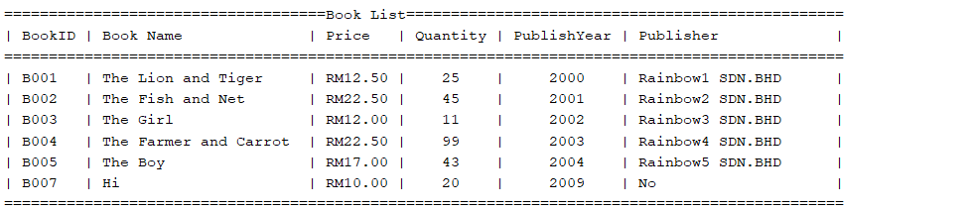

After modified:

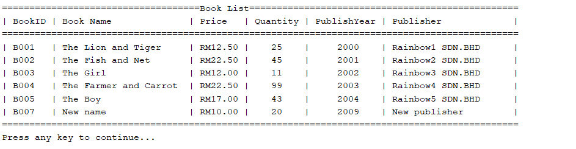

**5.5 Delete Book**

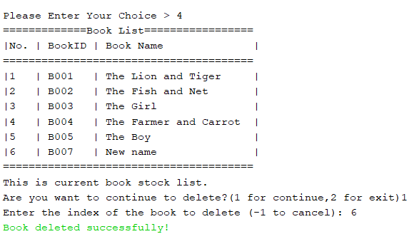

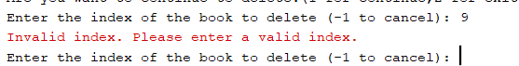

After a user enters ‘4’,this function is for the user to delete the book from the current book list.A current book stock list will be displayed.A message prompt will ask user whether want to continue for deleting or not,1 for continue,2 for return back to menu.After user enter 1,then will let user to enter no. of book that user want to delete.If the no. of book entered by the user is not in the list,then error message will be displayed and ask user to enter again.When user enter valid no. then successful message will be displayed.

Before delete:



After delete:

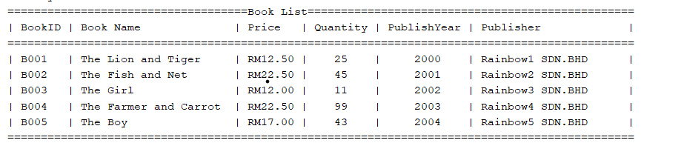

6 Report Module

**6.1 Report Selection Menu**

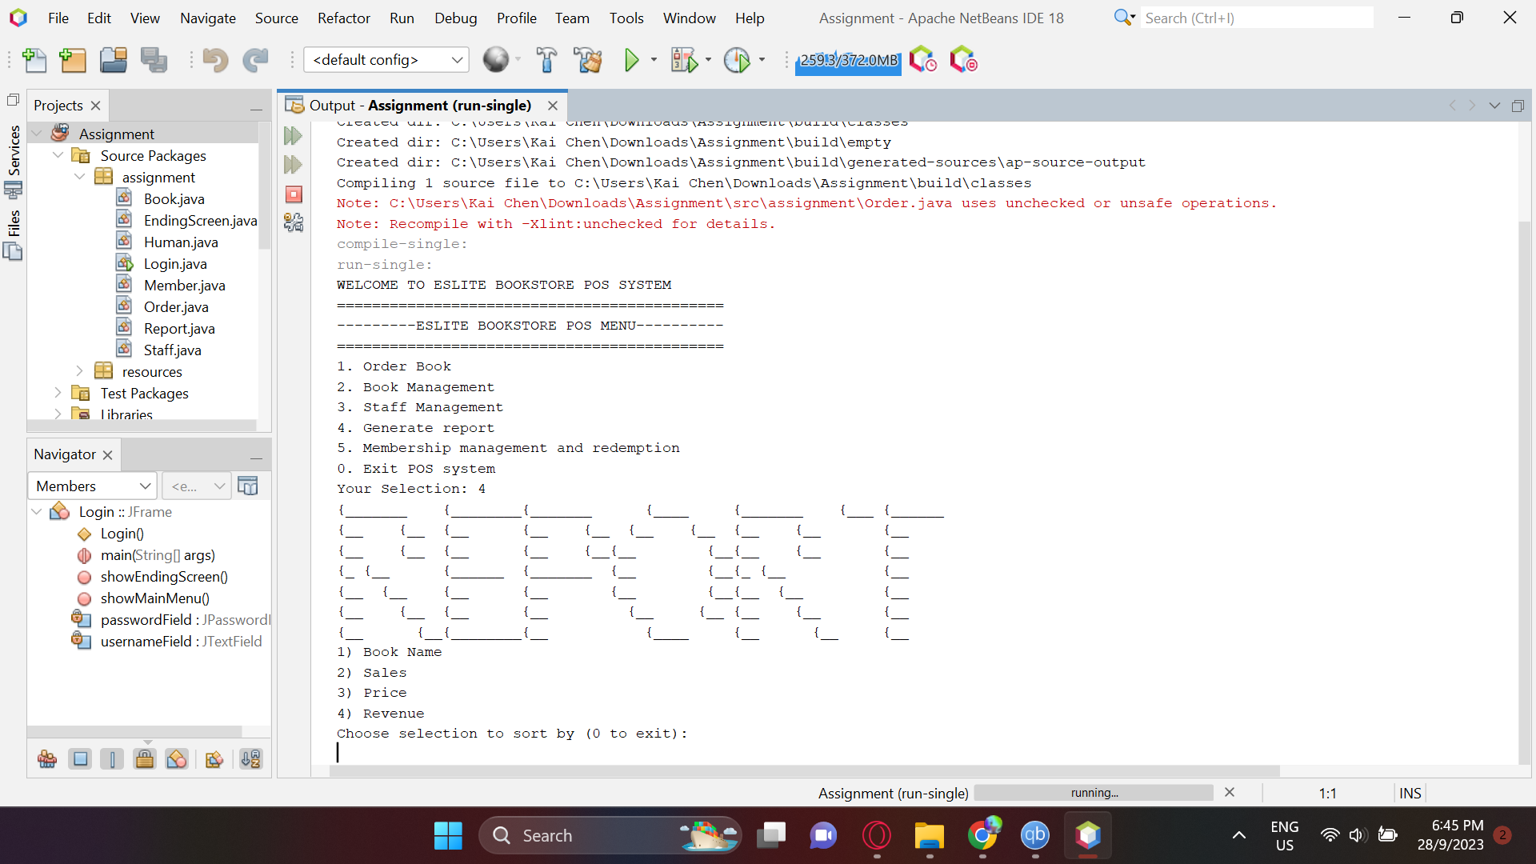

**After selecting 4 from the main menu it will bring us to the report module. Here we type in which ways we want the report to be sorted and displayed.**

**6.15 Validations**

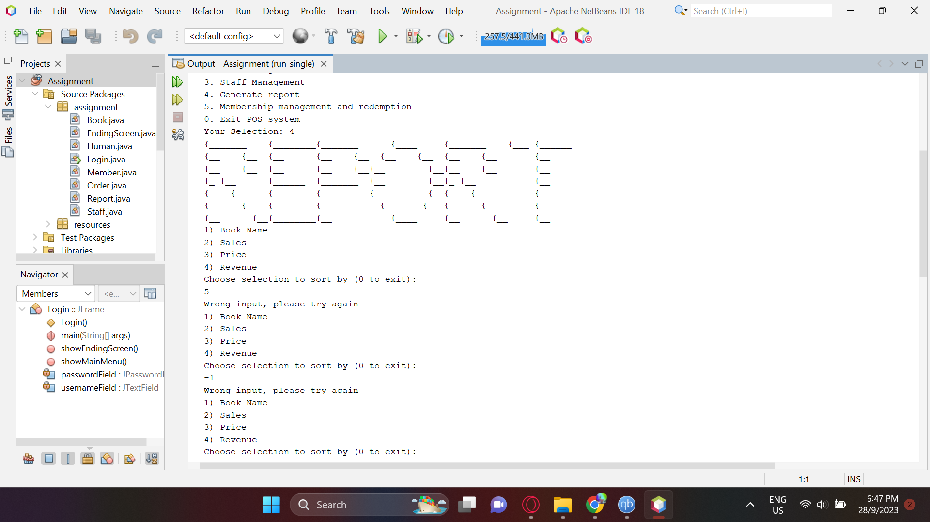

**There's validation to ensure the number inputted is in use or not.**

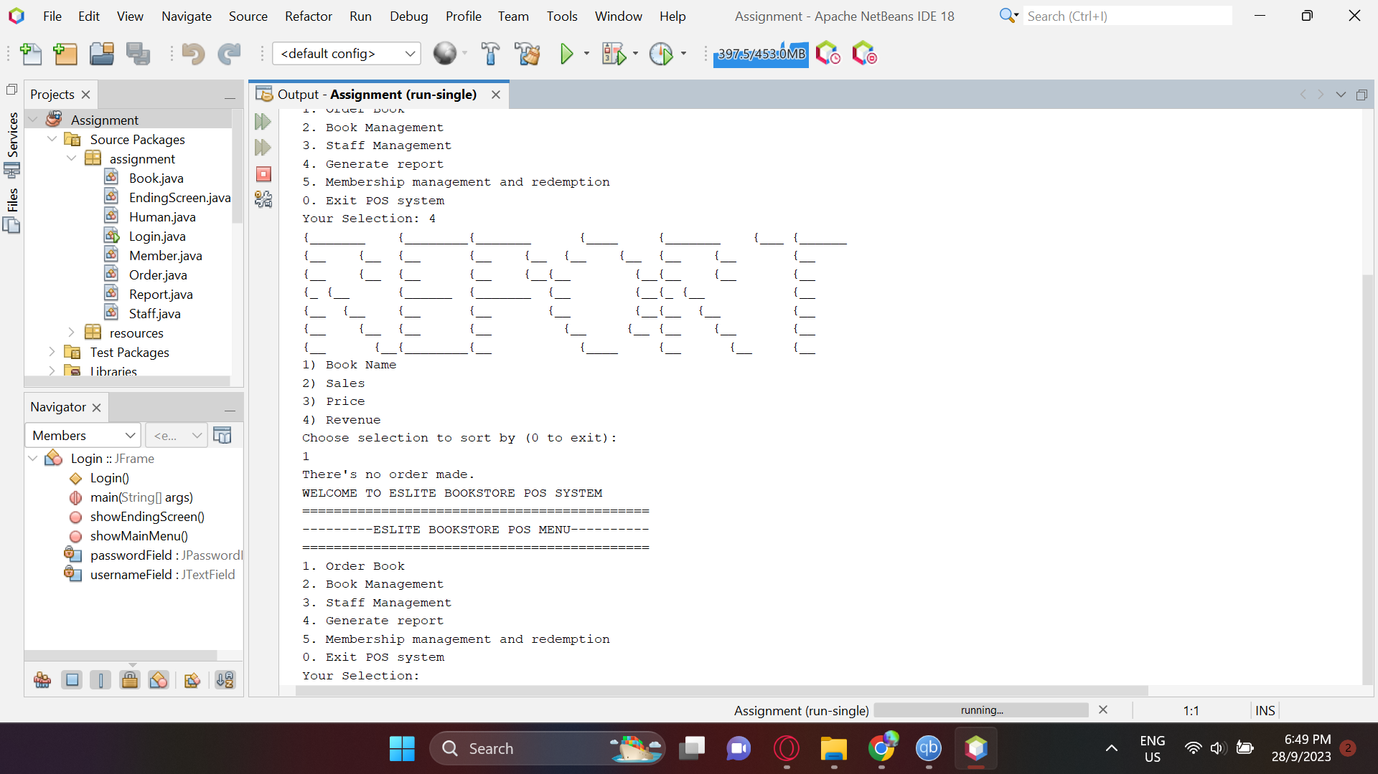

**Because the report module is reporting on Orders made so if we don't order anything and use the report module there will be feedback about not having any orders being displayed to remind them.It will jump back to the main menu selection screen after feedback is displayed.**

**6.2 Report in single order**

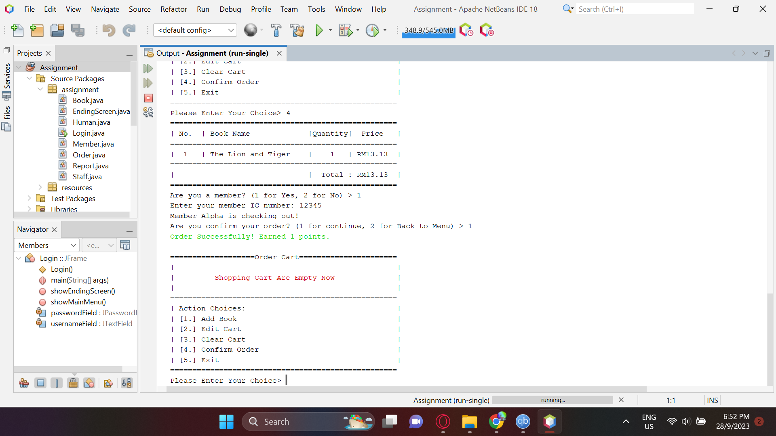

**Let's start off by only buying one book in order module and see how the report works.**

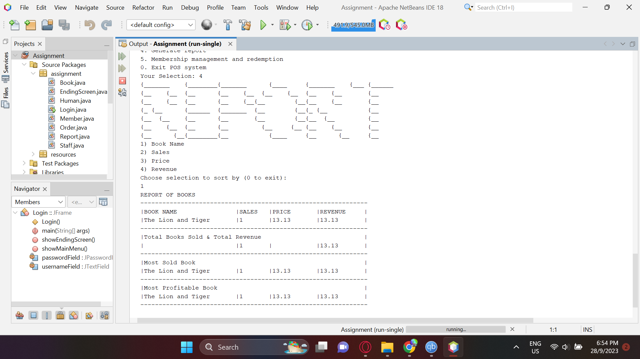

**It'll print out the book's name that we ordered,the amount bought,the price as well as how much we get from the book(revenue).**

**After listing out the books it will display the subtotals of the sales of all books as well as subtotal for revenue.After that it will print out the most sold book that is decided by the sales amount as well as the most profitable book that is decided by the largest revenue.**

**6.3 Report in multiple orders**

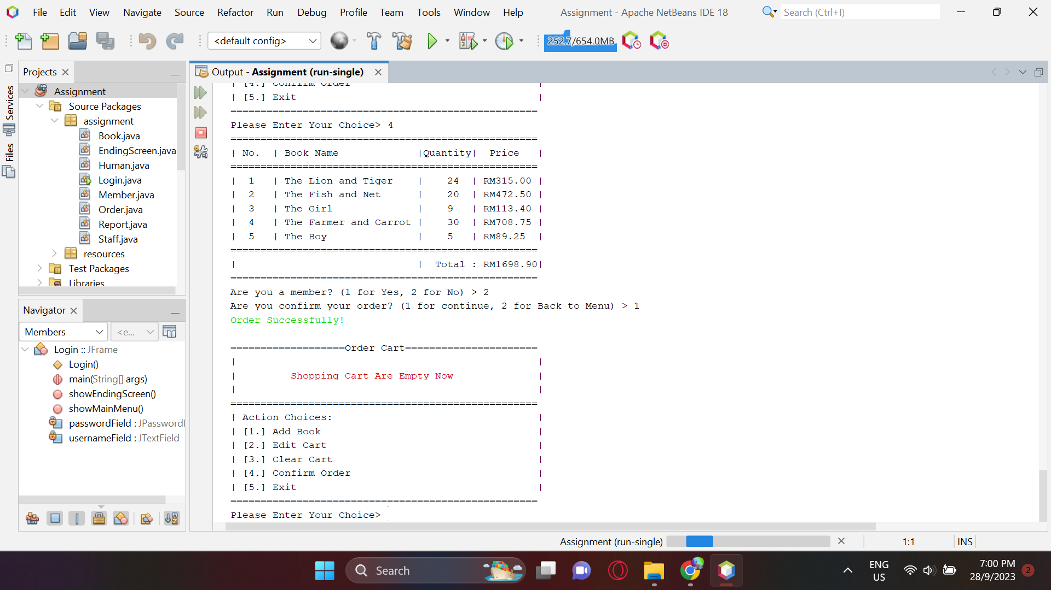

**This time we will be buying as much as we can in the order module and see how the report module handles this.**

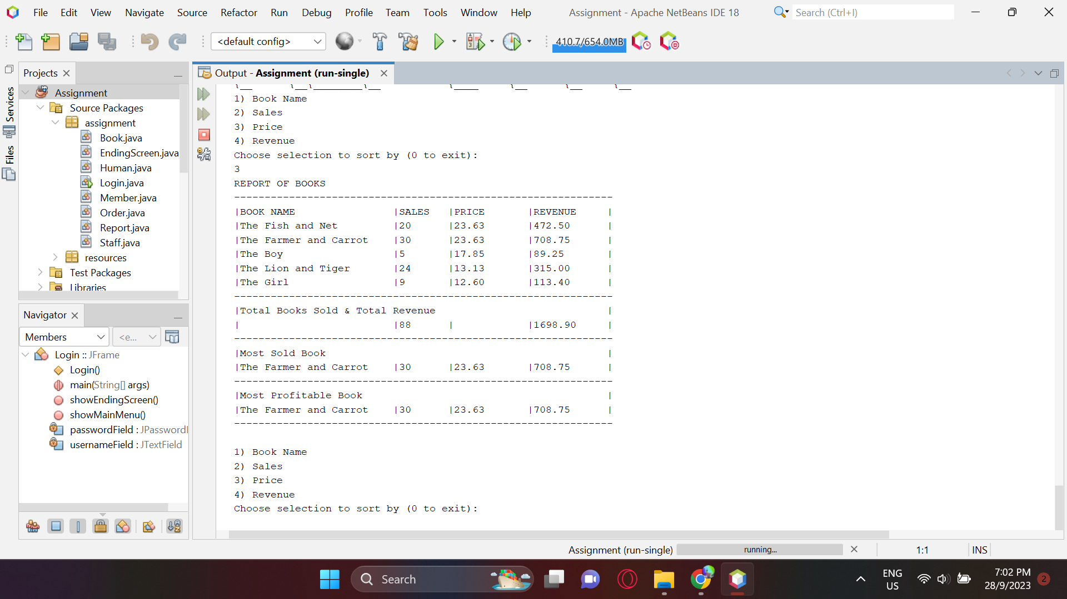

**This time I decided to display the report sort by descending order of Price.As we can see the most sold and most profitable book is the same as it is both the most sales and most revenue because of its book price.**

**6.4 Rest of the sortations**

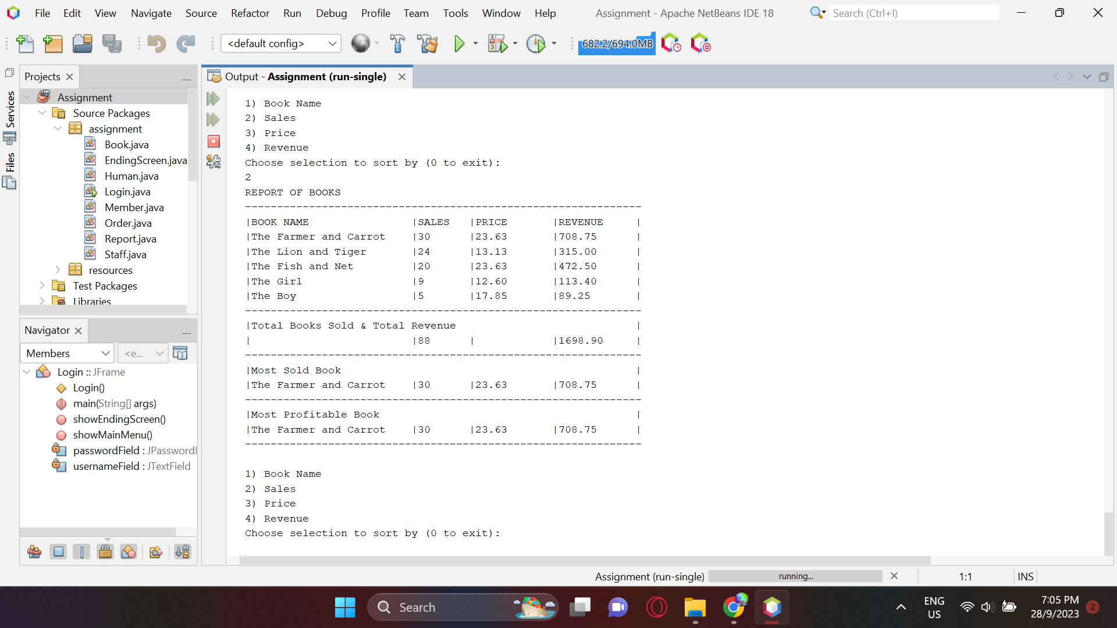

**This is sorting in Sales descending order.**

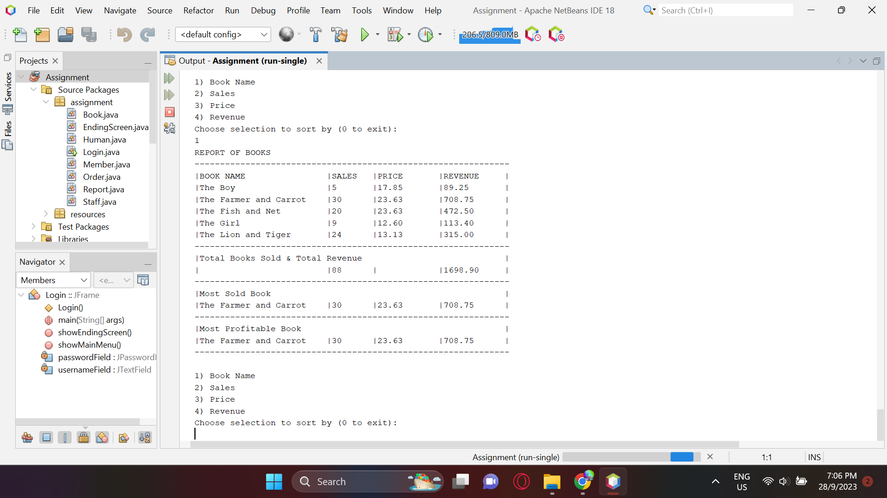

**Sort by book name alphabetical order(A-Z).**

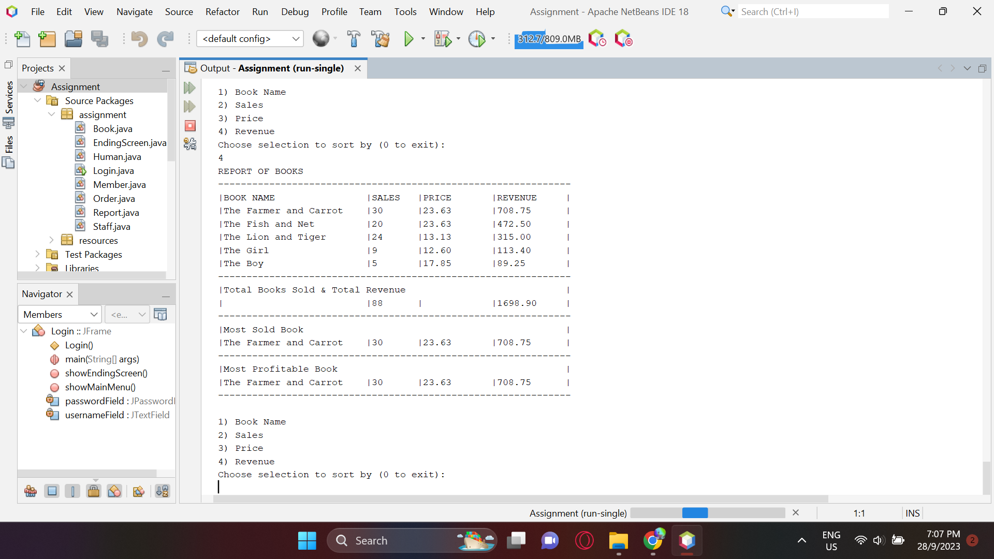

**Sort by revenue amount in descending order.**

**6.5 Most sold & Most Profitable**

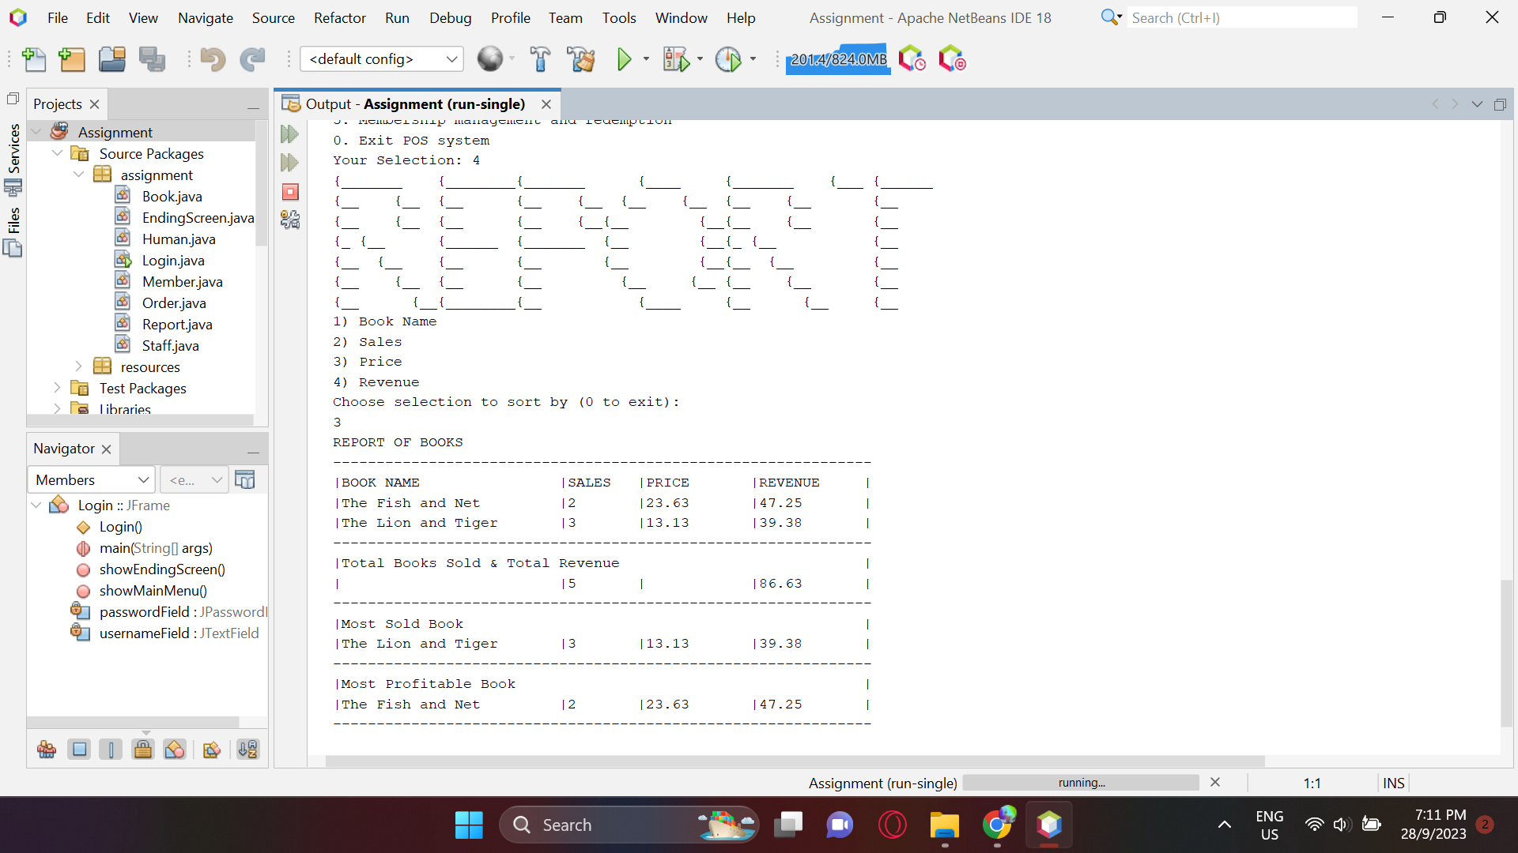

**A more prominent look at the report of how the most sold book and most profitable book is different.Even if the revenue of the book is higher doesn't mean it is the most sold book because it is decided by sales.Vice versa for deciding the most profitable book when the most sales doesn't always mean most**